

**Machine Learning for Predicting Epileptic Seizures Using EEG Signals**

**Hem Chaudhary**

**22106178**

Progress Report submitted for

ENGR7028 Engineering Project 1 (PG)

in partial fulfillment of the requirements for the degree of

Master of Engineering

Major: Electrical Engineering

Supervisor: Ali Meharabi

**School of Engineering, Design and Built Environment**

**Western Sydney University**

October 2025

# ABSTRACT

If you completed a Project Proposal for ENGR7028 Engineering Project 1 (PG), then this report is a continuation of that proposal with enriched contents.

All the pages have been formatted in the accepted font and margin alignment. This is a simple thesis template that can be used for directly typing in your content. However, if you paste your text into the document, do so with caution as pasting could produce varying results. When directly typing into the title page, the appropriate information should be filled in the required fonts. This thesis template includes answers to typical questions that students need addressed before writing the thesis.

When writing an abstract, bear in mind that it is a short descriptive summary of your thesis. The number of words accepted might vary, e.g. 200-300 words. Abstract is typically written last although it is the most important part of the thesis. It should concisely and succinctly articulate the essence of the report: the background, the scope of your project, the purpose, findings and conclusions. An abstract is neither paragraphed nor cited. It should not be written as a literature review or a discussion of results. In a simplistic manner, your abstract, in a few words, should answer the questions: why should we care about your research; how did you get your results; what did you learn, find, create, invent; and finally what do your results imply?

**\*\*--there are text and instructions throughout that need to be deleted as you add your own text --\*\***

# ACKNOWLEDGMENTS

You can write a formal statement to acknowledge contributions and assistance provided by others in completion of the thesis. Its customary and good manners to say thank you. The following and more have been seen in the acknowledgement of past theses: God, one’s advisor, one’s better half, parents, children, friends, classmates, lab-mates, lab technicians, lab assistants, favourable Prof, neighbours, physicians, exercise trainer(s), wiki, the maintenance guy, landlord, the school hockey team, secretary, department head …..

The present template is a substantially revised version of the thesis template created by Clarkson University Graduate Student Association for postgraduate students ([Thesis Template - Clarkson University](https://www.google.com/url?sa=t&rct=j&q=&esrc=s&source=web&cd=1&ved=0CB4QFjAA&url=https%3A%2F%2Fwww.clarkson.edu%2Fcee%2Fgraduate%2FGSA_thesistemplate_091008.doc&ei=5hpdVcTxO8vs8AXns4OYAw&usg=AFQjCNFAajuqtsVsiU7B6LOasJ4FPNDMSw&sig2=NBbGdhCvjAsz1q4-RBFNYg&bvm=bv.93756505,d.dGc)).

# TABLE OF CONTENTS

Chapter Page

ABSTRACT i

ACKNOWLEDGMENTS ii

TABLE OF CONTENTS iii

LIST OF TABLES iv

LIST OF FIGURES v

CHAPTER I: INTRODUCTION 1

CHAPTER II: LITERATURE REVIEW 2

Section Header (heading 2) 2

Sub heading (heading 3) 3

Sub-sub heading (heading 4) 3

Equations 3

Tables 4

Figures 5

CHAPTER III: AIM AND OBEJCTIVES 7

CHAPTER IV: METHODOLOGY 8

CHAPTER V: PRELIMINARY RESULTS 9

CHAPTER VI: RESEARCH PLAN AND TIMELINE 10

CHAPTER VII: CONCLUSIONS 11

REFERENCES 12

Appendix A: HEADING 13

The table of contents (ToC) is created with the REFERENCE tools within WORD. Go to References > Table of Contents, and choose an automatic style. The chapter titles and section headers should have been set to proper styles to create a ToC (usually, the Chapter is Heading 1, first level sub-heading is Heading 2, etc). It is important that the styles laid out in this template are used to maximize the benefits of the template and MS WORD options.

The table of contents can be easily updated every time after you revise this report by using right mouse button and clicking on “Update Field”. In this way, there is no need to copy and paste or retype your chapter and section titles.

# LIST OF TABLES

Table Page

Table 1: Steps in creating a table 6

Table 2: Styles used in this template 8

The above list of tables is created with the REFERENCE tools within WORD. Click on the following sequence: “insert, reference, index and tables, table of figures, (find “caption label” box set as – tables), okay” (these may change according to the version of MS Word that you are using).

This list can be easily updated every time after you revise this report by using right mouse button and clicking on “Update Field”. In this way, there is no need to copy and paste or retype table captions.

You need to use the table captions within the body of this report. The insertion of table captions in this manner also helps because word automatically renumbers the tables within the text when you insert another table in the middle. There is no need for you to renumber the tables manually.

# LIST OF FIGURES

Figure Page

Figure 1: Example photo with high resolution. 7

Figure 2: Example of high resolution graphic inserted with “paste special, as enhanced metafile” 7

The above List of Figures is created with the REFERENCE tools within WORD. Click on the following sequence: insert, reference, index and tables, table of figures, (find “caption label” box set as – Figures), okay.

The List of Figures can be easily updated every time after you revise this report by using right mouse button and clicking on “update field”. In this way, there is no need to copy and paste or retype figure captions.

You need to use the figure captions within the body of this report. The insertion of figure captions in this manner also helps because word automatically renumbers the tables within the text when you insert another table in the middle. There is no need for you to renumber the figures manually.

# CHAPTER I: INTRODUCTION

The main goal of this chapter is to identify a topic that is worthy of investigation, for your project. The introduction chapter provides an overall picture of your research aim. The aim should cover a few problems for the topic you plan to solve.

This template uses the MS WORD STYLES extensively to help keep your work in the proper format. These paragraphs use the “report-body text” style that is set for Times New Roman, 12 point font with double spaced lines and extra spacing between paragraphs (no need for hard carriage returns). There are also styles for headers, equations, captions and bulleted lists that you can choose to use. See examples throughout this template.

The headings of chapters should be in bold capital of font size 14. Each chapter should start from a new page. Page numbers are required.

# CHAPTER II: LITERATURE REVIEW

Literature review is an essential part of research methodology. In this chapter, you need to provide a critical review of existing methods in references, in relation to the problems described in Chapter I.

In this chapter, you need to describe the approaches used in existing methods to tackle the problems in your project topic and compare them against some criteria. This type of review is called critical review.

The literature review may cover:

* the fundamental science, math, engineering concepts related to your project topic,
* what part of your project topic has ever been investigated before and what has not, (some of this may have been included in the introduction)
* how does your project topic relate to that done by others,
* how have others defined/measured/identified the key concepts of your project topic,
* what data sources have you used or have other researchers used in developing general explanations for observed variations in a behaviour or phenomenon in a concept in your project topic.

The literature review should not be limited to the above questions only.

Bullets can be single spaced. The above bullets are in the style “thesis-bullets”. When you type bulleted text, highlight the bulleted text and then select “thesis-bullets” from under the format, style menu to automatically change their formatting as above.

## Section Header (heading 2)

The section header should have capital lead letter of each word.

Given the length of each chapter, it is required to use headers and sub headers (possibly sub-sub headers). These can be numbered or one can just rely on different formats. The section headers in this document are labelled “heading 2” (“heading 1” was used for chapter titles). The heading styles formats should be consistent throughout the document as it helps significantly in creating the automatic table of contents.

### Sub heading (heading 3)

The subheadings here have the style of sentence case. than the section headers.

Sub-sub heading (heading 4)

You can even get to another level of headers, defined here as “heading 4”. The table of contents, however, is currently set up to just include three levels of headers.

### Equations

Equations can be created in MS WORD equation editor or they can be created with other software. Equations should be numbered. They can be numbered within each chapter (e.g., 2.1, 2.2) or they can be numbered sequentially throughout the entire thesis. A caption can be created for equation numbering, for example, ‘(’ or ‘(2’. Can be created as captions then used for equation numbering. Equations should be indented or centred with the equation number to the right. The example below and associated “thesis-eqn” style can be used for all your equations.

|  |  |
| --- | --- |
|  | (2.1) |

where ‘(2.’ is a created caption. Number ‘1’ is automatically assigned by WORD and ‘)’ is added as a caption content. The reason for placing the equation and the equation number in a two column table is for the convenience of cross referencing later. The borders of the equation table can be masked by selecting ‘No borders’ in “Table Tools”, “Design” menu. A clean equation is shown as follows

|  |  |
| --- | --- |
|  | (2.2) |

When this equation is cross referenced, simply type ‘Eq.’, then go to “Cross-reference” under “References” menu, select ‘(2.’ In “Reference type” and insert the entire caption ‘(2.2)’, you will get Eq.(2.2).

### Tables

Tables should have meaningful information with descriptive headers. You can use the “thesis-table caption” style to define your captions and refer to the table in the text with a “cross reference” (Table 1). MS Word re-numbers table captions automatically when new tables inserted. But you need to right click on any cross references and “update field” if there are changes.

Table 1: Steps in creating a table

|  |  |
| --- | --- |
| **Step #** | **Instruction** |
| Create table caption | Insert, reference, caption, table |
| Format the caption | Format, style, “thesis-table-caption” |
| Create table | Table, insert… |
| Format the table | The formatting of the table can vary, including use of single space as appropriate. Most journals require that tables are formatted using table style “Table Simple 1” format. |
| Reference the table from the text | With the cursor at the location you want to cite the table: insert, reference, cross reference, table, label and number only. |

### Figures

Figures and illustrations are a necessary means of communicating technical information. Often times, figures included in the background/literature review section are copied from existing copyrighted information. In all cases, this is technically inappropriate without also receiving permission from the copyright owner. Citing the source of the figure is not sufficient.

Resolution of figures is often a problem in theses. Resolution should be >300 dpi, preferably 600dpi (Figure 1). You should note that saving images as jpeg files is a sure way to lower the resolution to an unacceptable extent. From experience, a good way is to copy your graphic (for example from PowerPoint or excel) and when pasting it into word, use the “paste special” “as an “enhanced metafile” (Figure 2). This also substantially reduces the resulting file size in comparison with pasting graphs in as excel graphics.

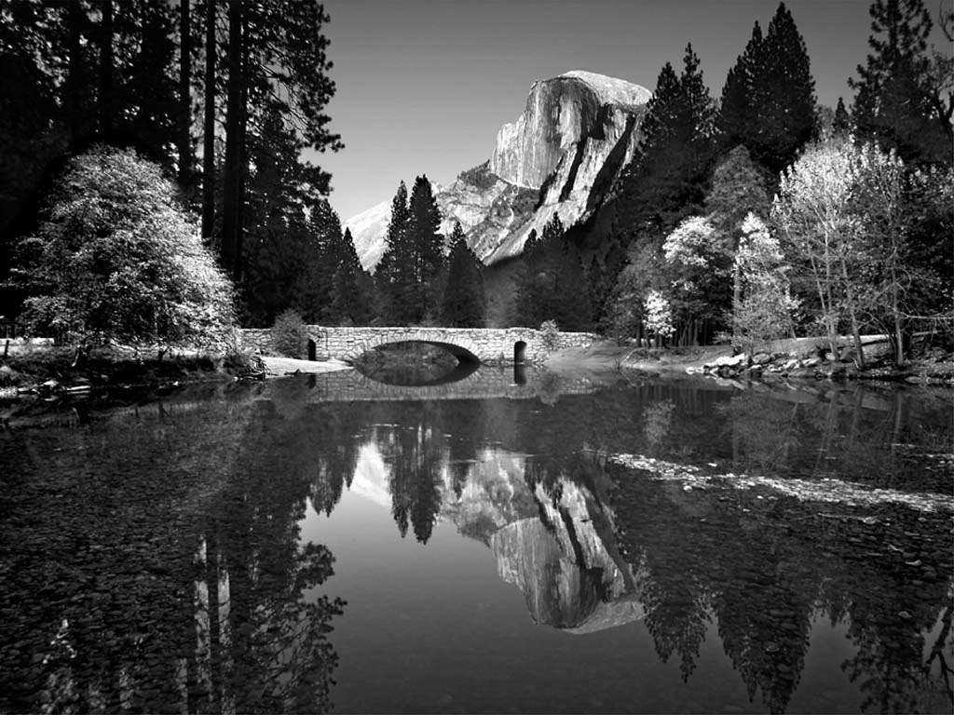

Figure 1. Example photo with high resolution.



Figure 2. Example of high resolution graphic inserted with “paste special, as enhanced metafile”.

# CHAPTER III: AIM AND OBEJCTIVES

Based on the critical literature review in Chapter II, you need to describe research questions (i.e., research gaps) in this chapter.

After research questions, you need to describe the aim and objectives of your research. This chapter can have 1-2 pages.

It should be noted that an aim of your project defines the OUTCOME, i.e. what will be learned/obtained. They are not a statement of the approach or tasks that are required to meet the aim. Some examples of reasonable aims:

* Determine the effect of Marangoni convection on mixing of molten glasses
* Predict the extent of mechanical degradation of polymers

The above examples define the resulting outcome (prediction, effect on…) so they are aims. The related tasks or research approach could be:

* Solve a set of coupled non-linear PDEs…
* Perform experiments on…

The above statements define the required steps, and are objectives; they do not define the outcome so they are NOT aims.

# CHAPTER IV: METHODOLOGY

In this chapter, you need to describe the detailed methods, for the research questions and specific objectives given in Chapter III.

Please do not include literature review in this chapter. If the description of methodology requires knowledge/skills in some references, they should be described in the literature review chapter and ONLY cited in this chapter.

These paragraphs are in “thesis-body text”. Other styles including captions, headers etc. can be used as presented in the previous chapters. Table 2 summarizes all of the styles that can be used with this template.

Table 2. Styles used in this template

|  |  |
| --- | --- |
| Style name | When used |
| Heading 1 | Chapter titles |
| Heading 2 | Primary headers |
| Heading 3 | Sub headers |
| Heading 4 | Sub-sub headers |

# CHAPTER V: PRELIMINARY RESULTS

You might have conducted preliminary or limited experiments/simulations/field surveys. If so, you may include such results, findings, discussion of results OR manuscripts. It is best to also reiterate information in your literature review to help substantiate the findings of your research. If the result section is presented separately from a discussion section, the factual results of your project will be presented in this section. Information may be presented in tables or figures (i.e. graphs, diagrams, maps, photographs, etc.); however, these illustrations should not stand alone. An explanation of the relevant findings must be included. The results may be structured around the questions, hypotheses or themes. The discussion should draw together the findings from your research and relate it to the literature or current knowledge of the topic. It should make sense of, or explain, what you have found and discuss what your findings mean.

# CHAPTER VI: RESEARCH PLAN AND TIMELINE

You need to provide a timeline on how your project is managed in Project 1 and how your project is planned in Project 2, using a Gantt chart or a table.

You also need to provide details on how problems are handled in Project 1. Details can be described based on the minutes of all the meetings.

# CHAPTER VII: CONCLUSIONS

You need to summarize what you have done in Project 1.

If you have not done preliminary study/analysis, you can describe your understanding. If you have done preliminary study/analysis, you can describe your findings.

This chapter can have one or more paragraphs.

# REFERENCES

Include all references: articles, media facts, books, reports, regulations, internet articles, papers that you referenced from the text. You need to use [HARVARD](https://library.westernsydney.edu.au/__data/assets/pdf_file/0008/1943486/cite_Harvard.pdf) referencing style. In the text, citations can be (First, 2008) or (First and Second, 2007) or (First et al., 2007) (if more than two authors). The computer software “EndNote” or the MS WORD tools – “insert, reference, footnote, endnote” (or “cross reference” if you refer to the same reference more than once) should be used to help you organize and manage your references.

References can be written in single space with extra space between references as in the format below. There are many different ways to arrange the information and punctuation in a reference listing. The most important thing is to make sure all references are complete and that the format of your references is consistent throughout.

**REFERENCES**

First, S.Z. (2008). How to cite a complete journal reference. *J. Complete Thesis*. 1(2): 47-52.

First, S.Z., Second, W.S. (2007). How to cite a complete conference proceedings paper. In: *Proceedings*, 2nd International meeting of Masters Students, Paper # XW15 (Potsdam NY, November, 2007).

# Appendix A: HEADING

Type or paste your appendices here. Appendices are a place to organize and include all of the “extra” material that is important to your research work but that is too detailed for the main text. Examples can include: specific analytical methods, computer code, spreadsheets of data, details of statistical analyses, etc. But, these materials do not speak for themselves. There should be a reference to these materials from the main chapters (complete details included in Appendix A) and there should be some text at the beginning of each appendix to briefly explain what the information is and means that is included in that appendix.